
Your GDM Logbook

If you did not receive a logbook with your glucometer for your pregnancy, this guide provides a logbook sheet for your use or will help you create your own logbook.

Please track these results:
- Before breakfast (fasting) blood sugar
- 1 hour after breakfast blood sugar
- 1 hour after lunch blood sugar
- 1 hour after dinner blood sugar

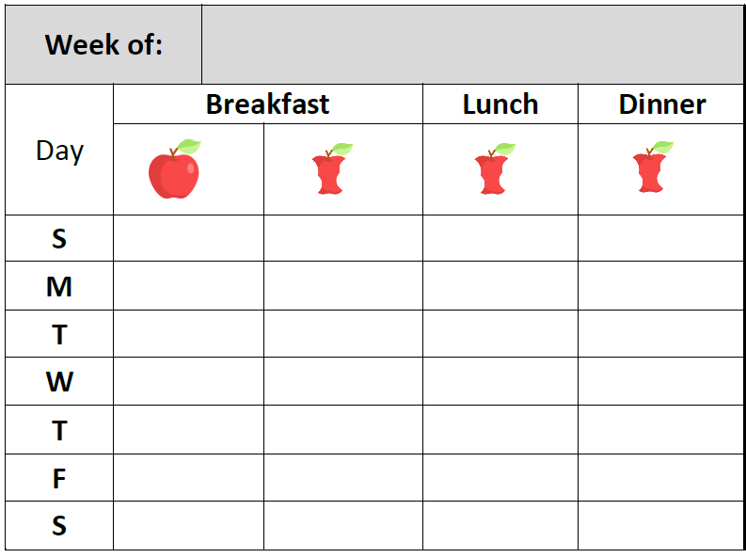

Before breakfast (fasting) bloog sugar is indicated with a full, uneaten apple. |  | 1 hour after each meal blood sugar is indicated with an apple core. | 

Page 2 provides an alternative to a logbook with the 4 numbers you need to track in your pregnancy. You can also create your own system in a small notebook or on excel. Find what works best for you!
Week of: |  |  |  |  |  | Week of:
Day | Breakfast |  |  | Lunch | Dinner | Day | Breakfast |  |  | Lunch | Dinner
 |  |  |  |  |  |  |  |  |  |  | 
S |  |  |  |  |  | S
M |  |  |  |  |  | M
T |  |  |  |  |  | T
W |  |  |  |  |  | W
T |  |  |  |  |  | T
F |  |  |  |  |  | F
S |  |  |  |  |  | S
Week of: |  |  |  |  |  | Week of:
Day | Breakfast |  |  | Lunch | Dinner | Day | Breakfast |  |  | Lunch | Dinner
 |  |  |  |  |  |  |  |  |  |  | 
S |  |  |  |  |  | S
M |  |  |  |  |  | M
T |  |  |  |  |  | T
W |  |  |  |  |  | W
T |  |  |  |  |  | T
F |  |  |  |  |  | F
S |  |  |  |  |  | S
Week of: |  |  |  |  |  | Week of:
Day | Breakfast |  |  | Lunch | Dinner | Day | Breakfast |  |  | Lunch | Dinner
 |  |  |  |  |  |  |  |  |  |  | 
S |  |  |  |  |  | S
M |  |  |  |  |  | M
T |  |  |  |  |  | T
W |  |  |  |  |  | W
T |  |  |  |  |  | T
F |  |  |  |  |  | F
S |  |  |  |  |  | S


\

